Midterm Exam- Part 2

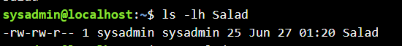

1. I changed the permissions of Salad, using the *chmod* command
2. 